Functions (Part 2 Overload, Templates and Recursion)

LAB # 07



Spring 2022

CSE-102L COMPUTER PROGRAMMING LAB

Submitted by: MUHAMMAD SADEEQ

Registration No.: 21PWCSE2028

Section: C

"On my honor, as student of University of Engineering and Technology, I have neither given nor received unauthorized assistance on this academic work.'

Student Signature: _____________________

Submitted to:

Engr. Abdullah Hamid

(July 2022)

Department of Computer Systems Engineering University of Engineering and Technology, Peshawar

# Lab 7: Functions (Part 2 Overload, Templates and Recursion)

## Objectives:

To understand the programming of recursive functions and overloading functions

To understand function programming, its types and function-call

## Tasks:

1. Print your name and registration number 10 times in C++ using recursion.
2. Write a C++ program where you take two values from user if the user enters one or two of the values zero instead of passing the zero values to the function let the function calculate default values if user enters values other than zero pass them to function and calculate their sum.
3. Write a function to find Sum of N natural numbers using Recursion.
4. Calculate the sum of odd natural numbers 1+3+5+7+……………. + n using Recursion. Take n as input from user.
5. Overload three functions with name “grade”, the first grade function should be non-returning void type with no parameter, void grade(), the second should have integer parameter and return type float, float grade(int marks) the third function should have float parameter and its return type should be char, char grade(float percentage). Your main() should only call the first function, the first function will prompt the user to enter marks then it will pass the marks to the second function where it will calculate the percentage and return the percentage to the first function, then the first function will send the percentage to the third function where it will calculate the grade based on the percentage will return the grade to first function in the form of char. Finally, the first function will display the grade as well as the marks and the percentage. Consider total marks = 150.
6. Write a C++ Program to Find Factorial of a Number Using Recursion.
7. C++ program to print Fibonacci series using recursion.
8. C++ program to calculate power of a number using recursion.

**COMPUTER PROGRAMMING LAB # 7**

**Answer #1**

**CODE:**

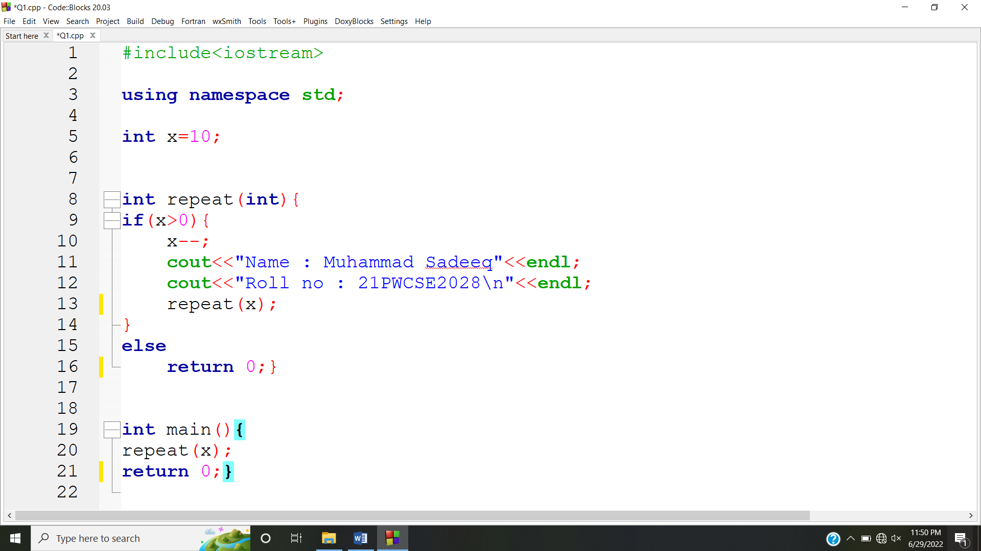**OUTPUT:**

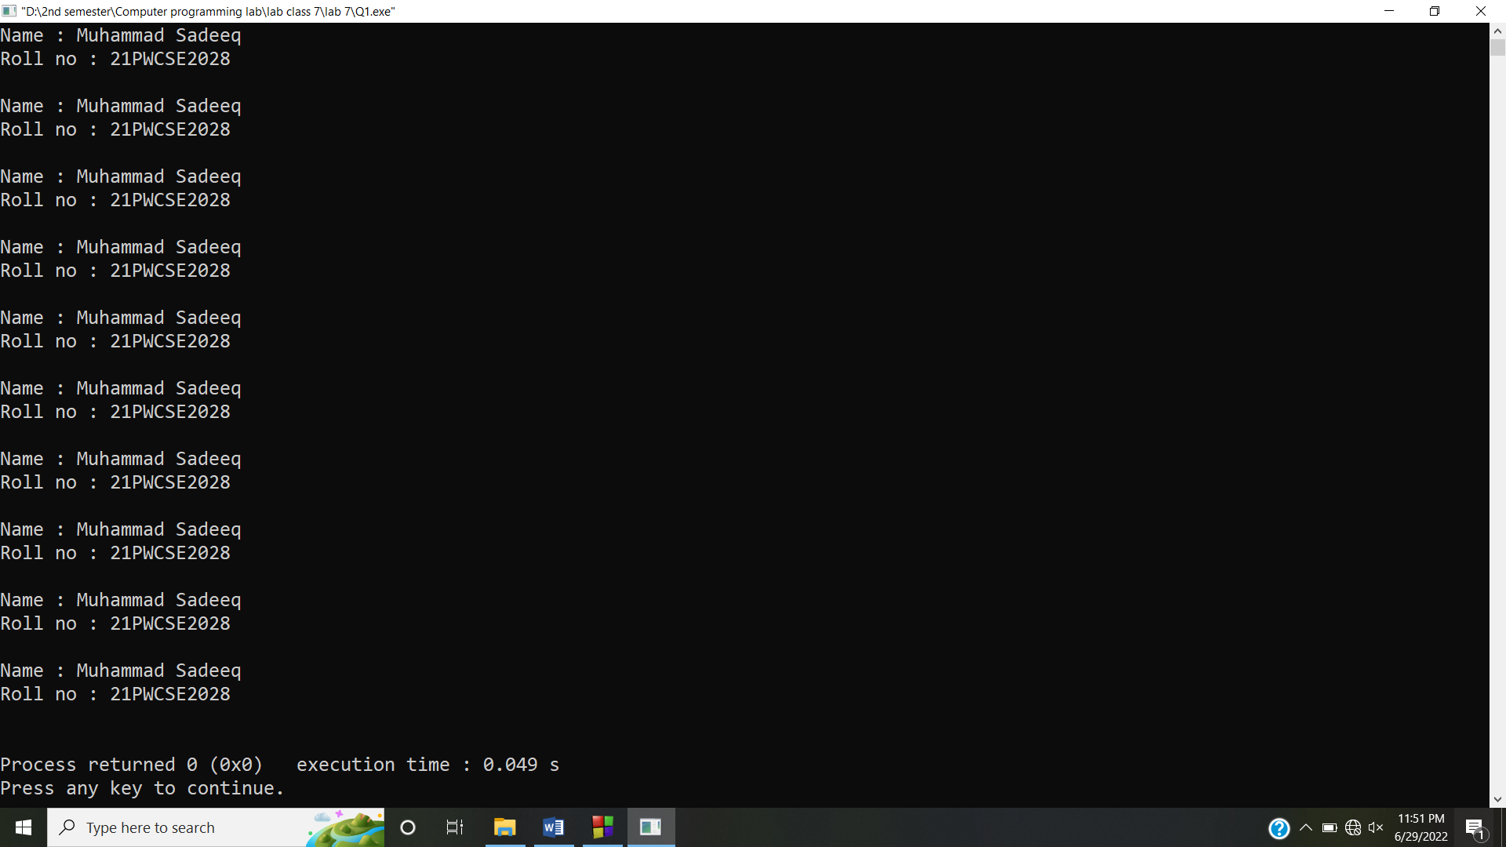

**Answer #2**

**CODE:**

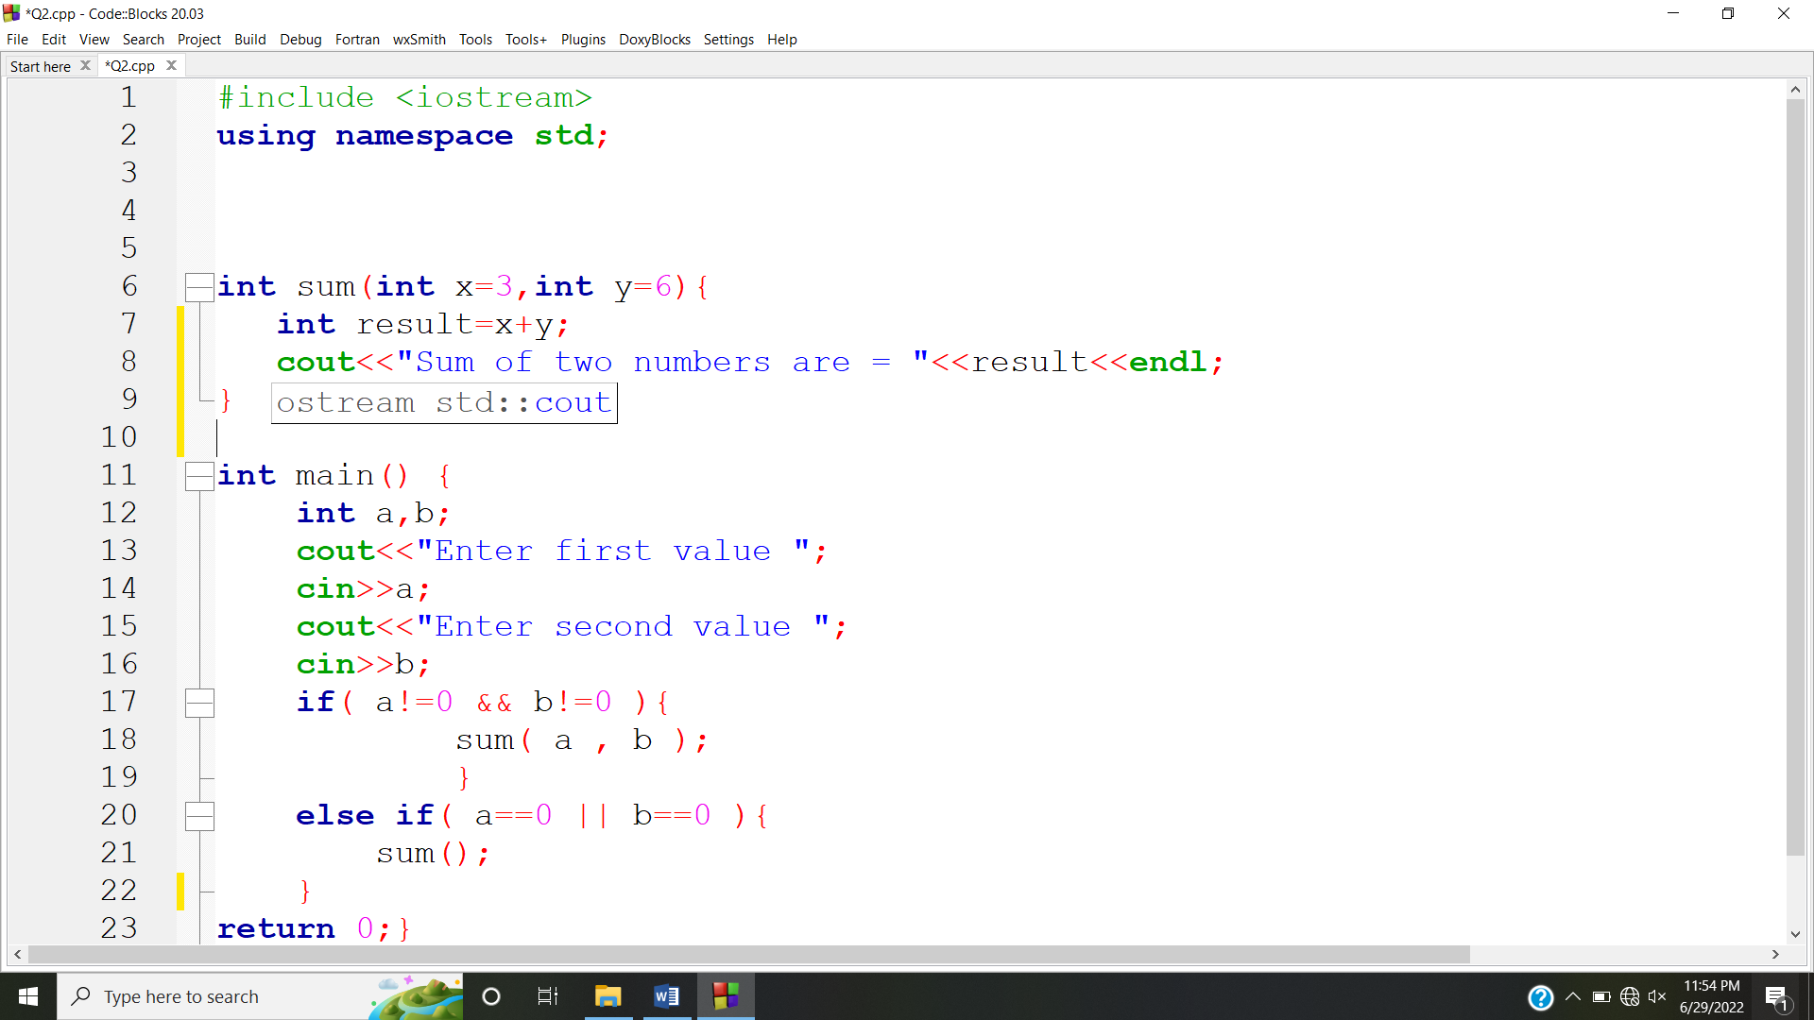

**OUTPUT:**

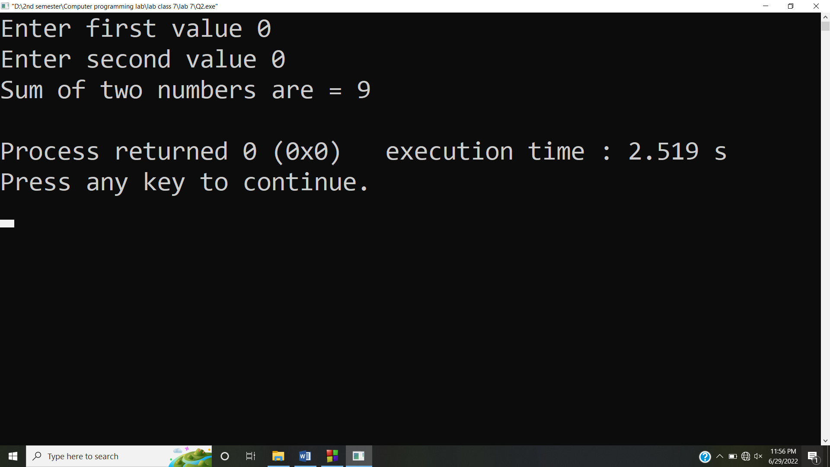

**Answer #3**

**CODE:**

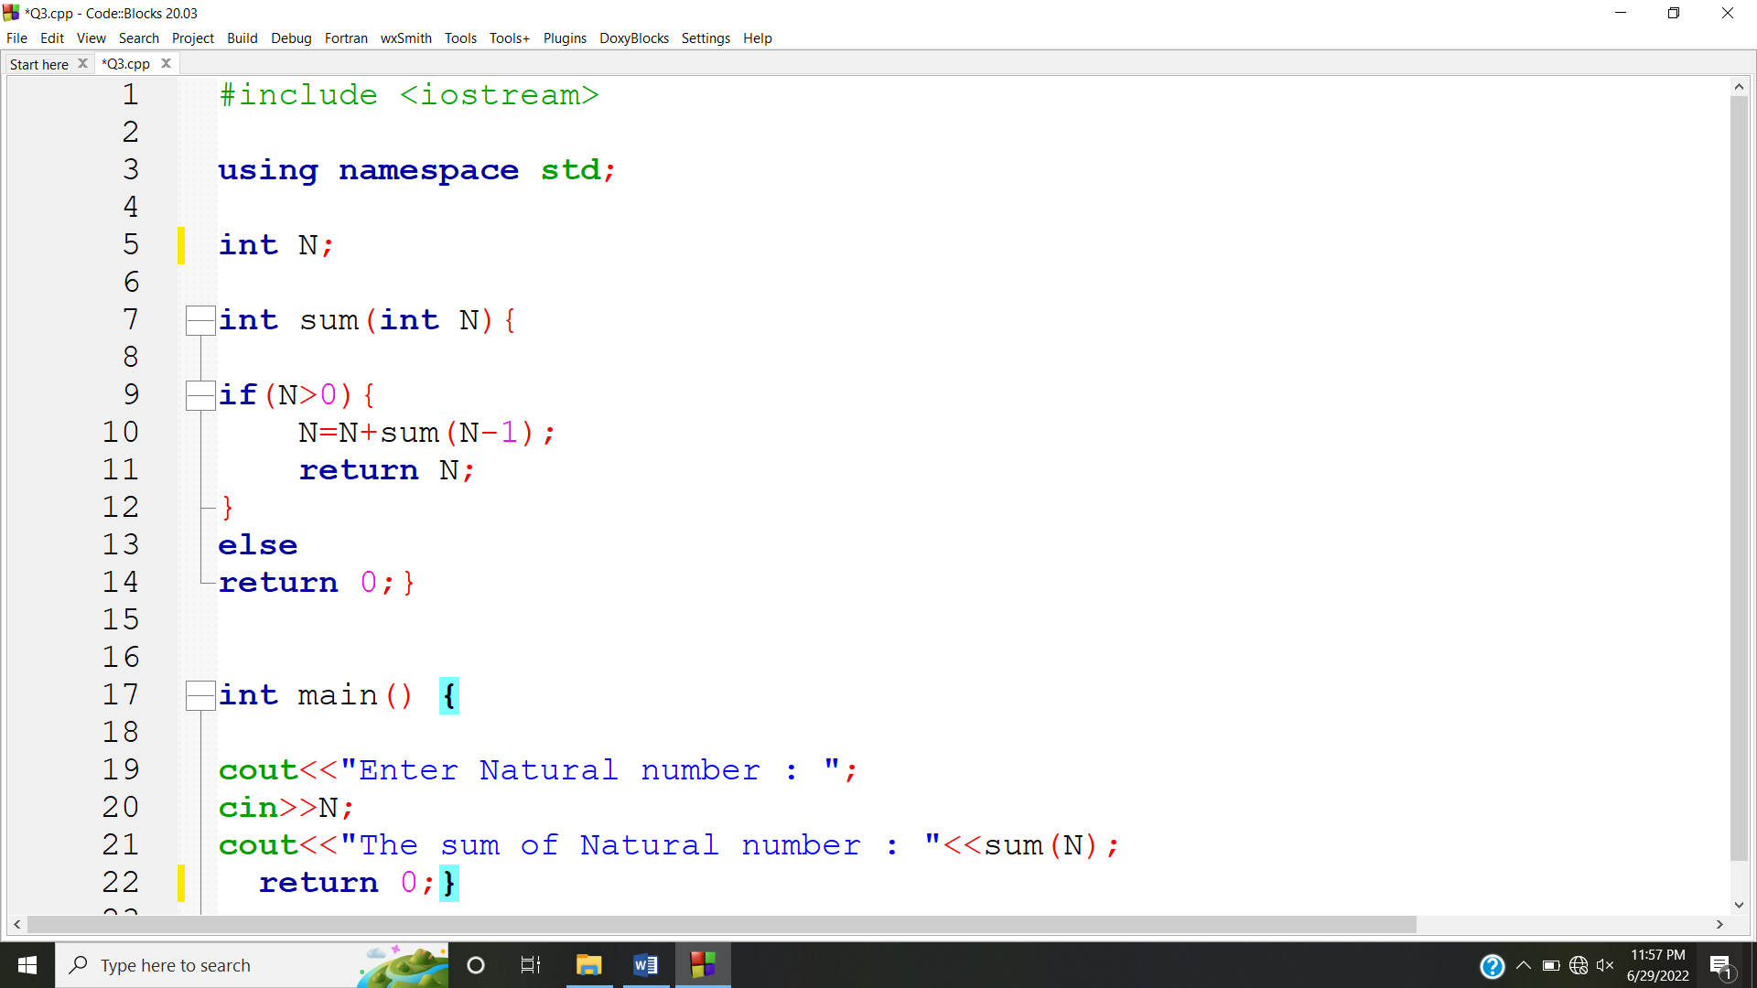

**OUTPUT:**

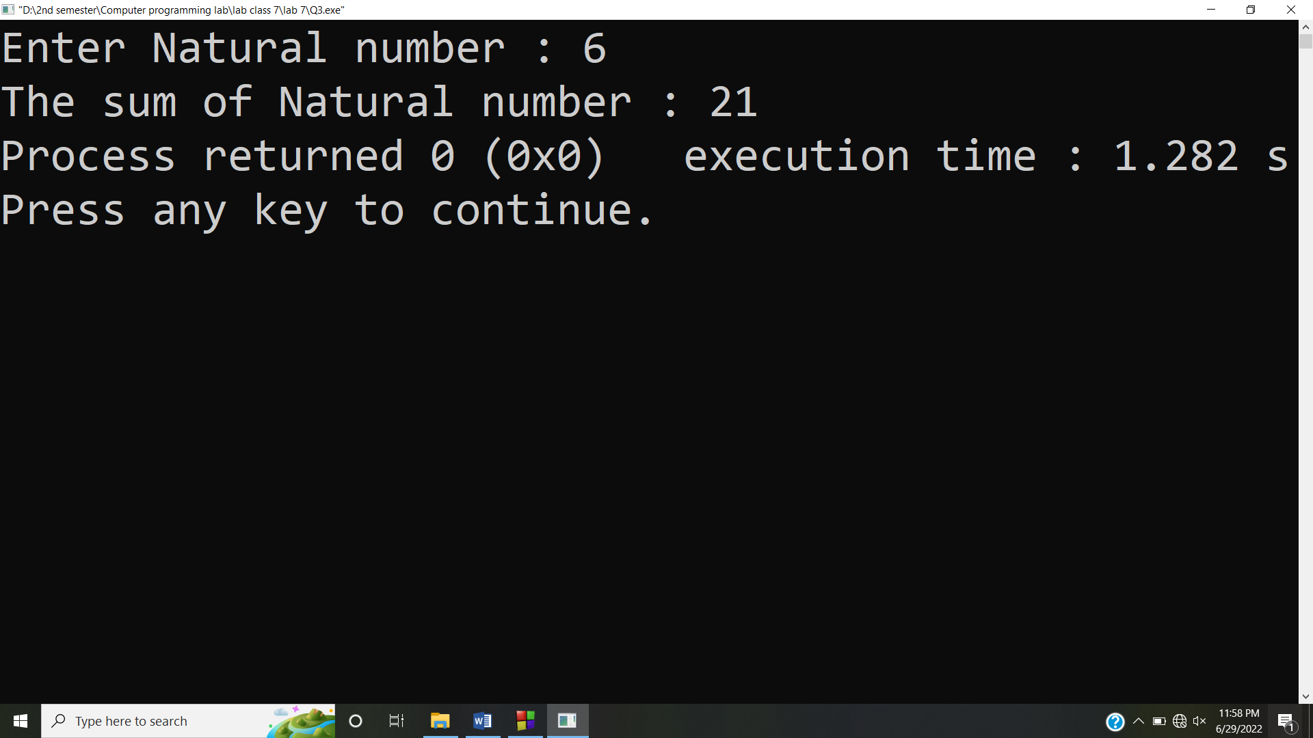

**Answer #4**

**CODE:**

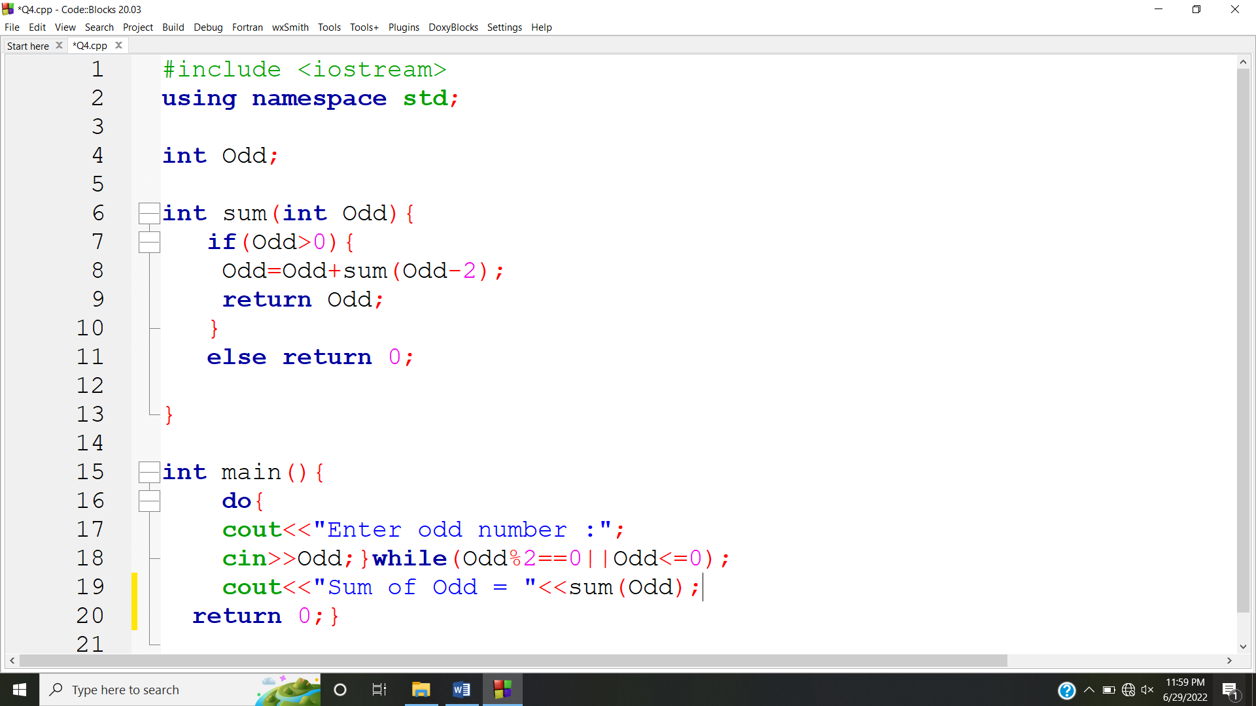

**OUTPUT:**

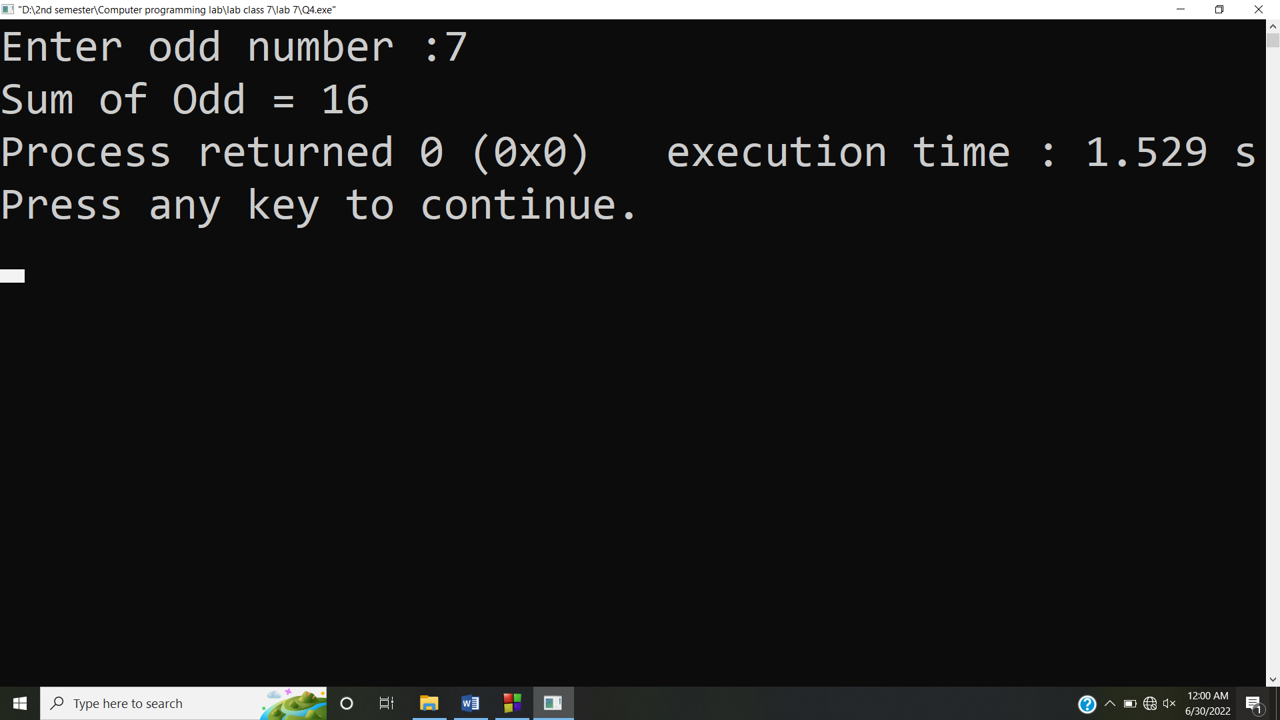

**Answer #5**

**CODE:**

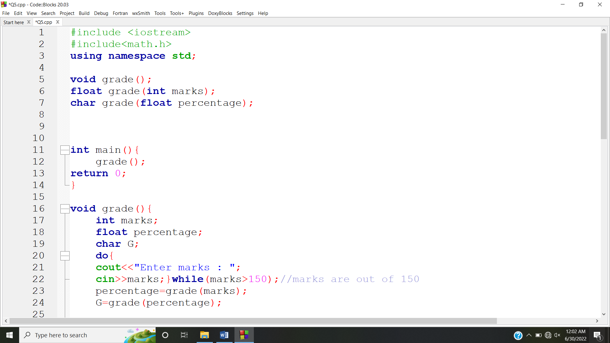

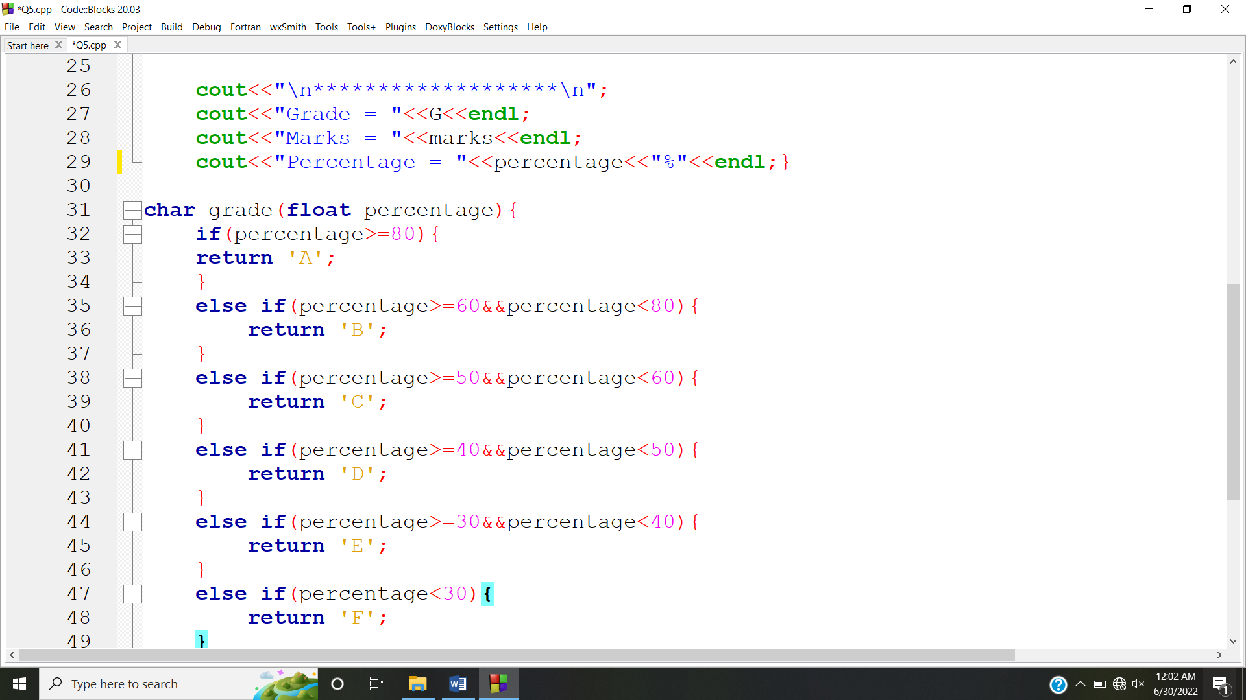

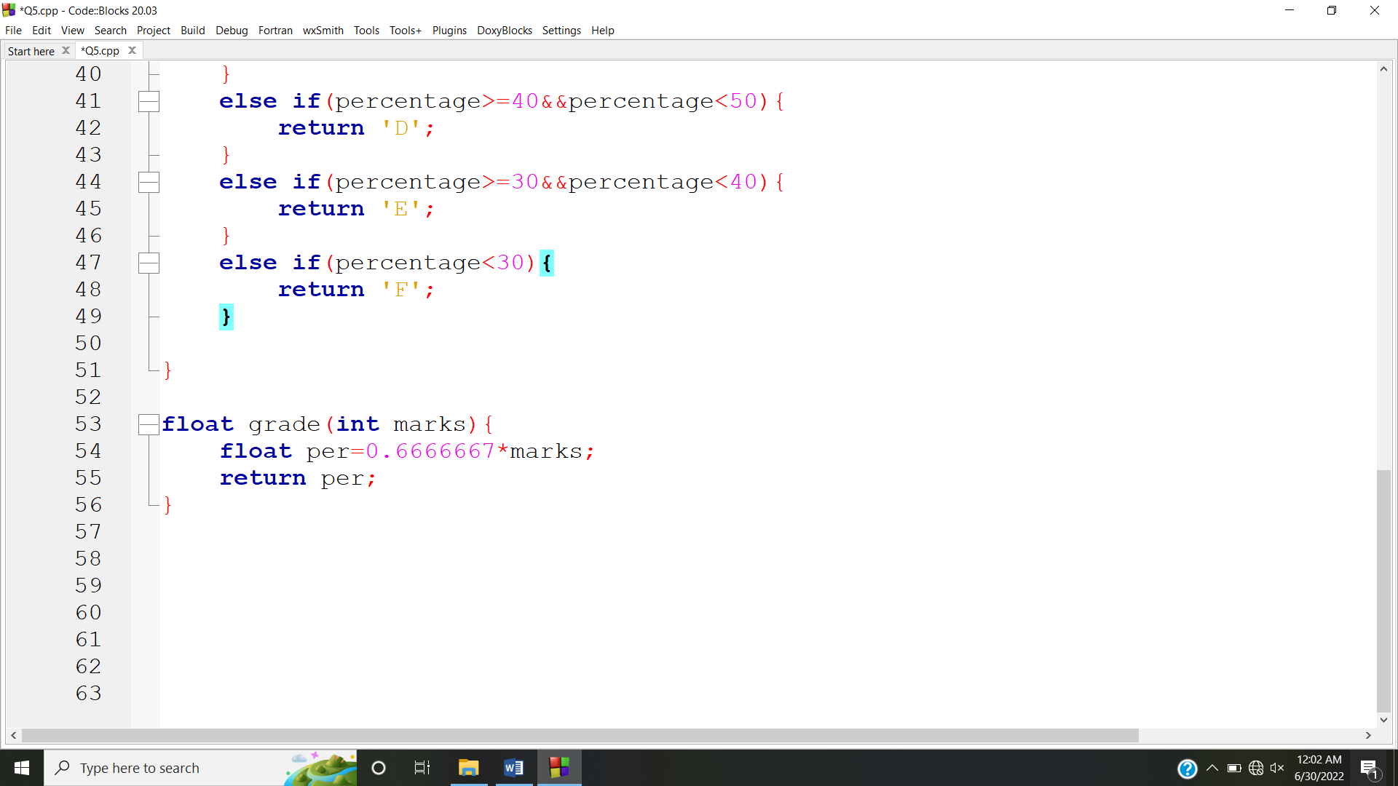

**OUTPUT:**

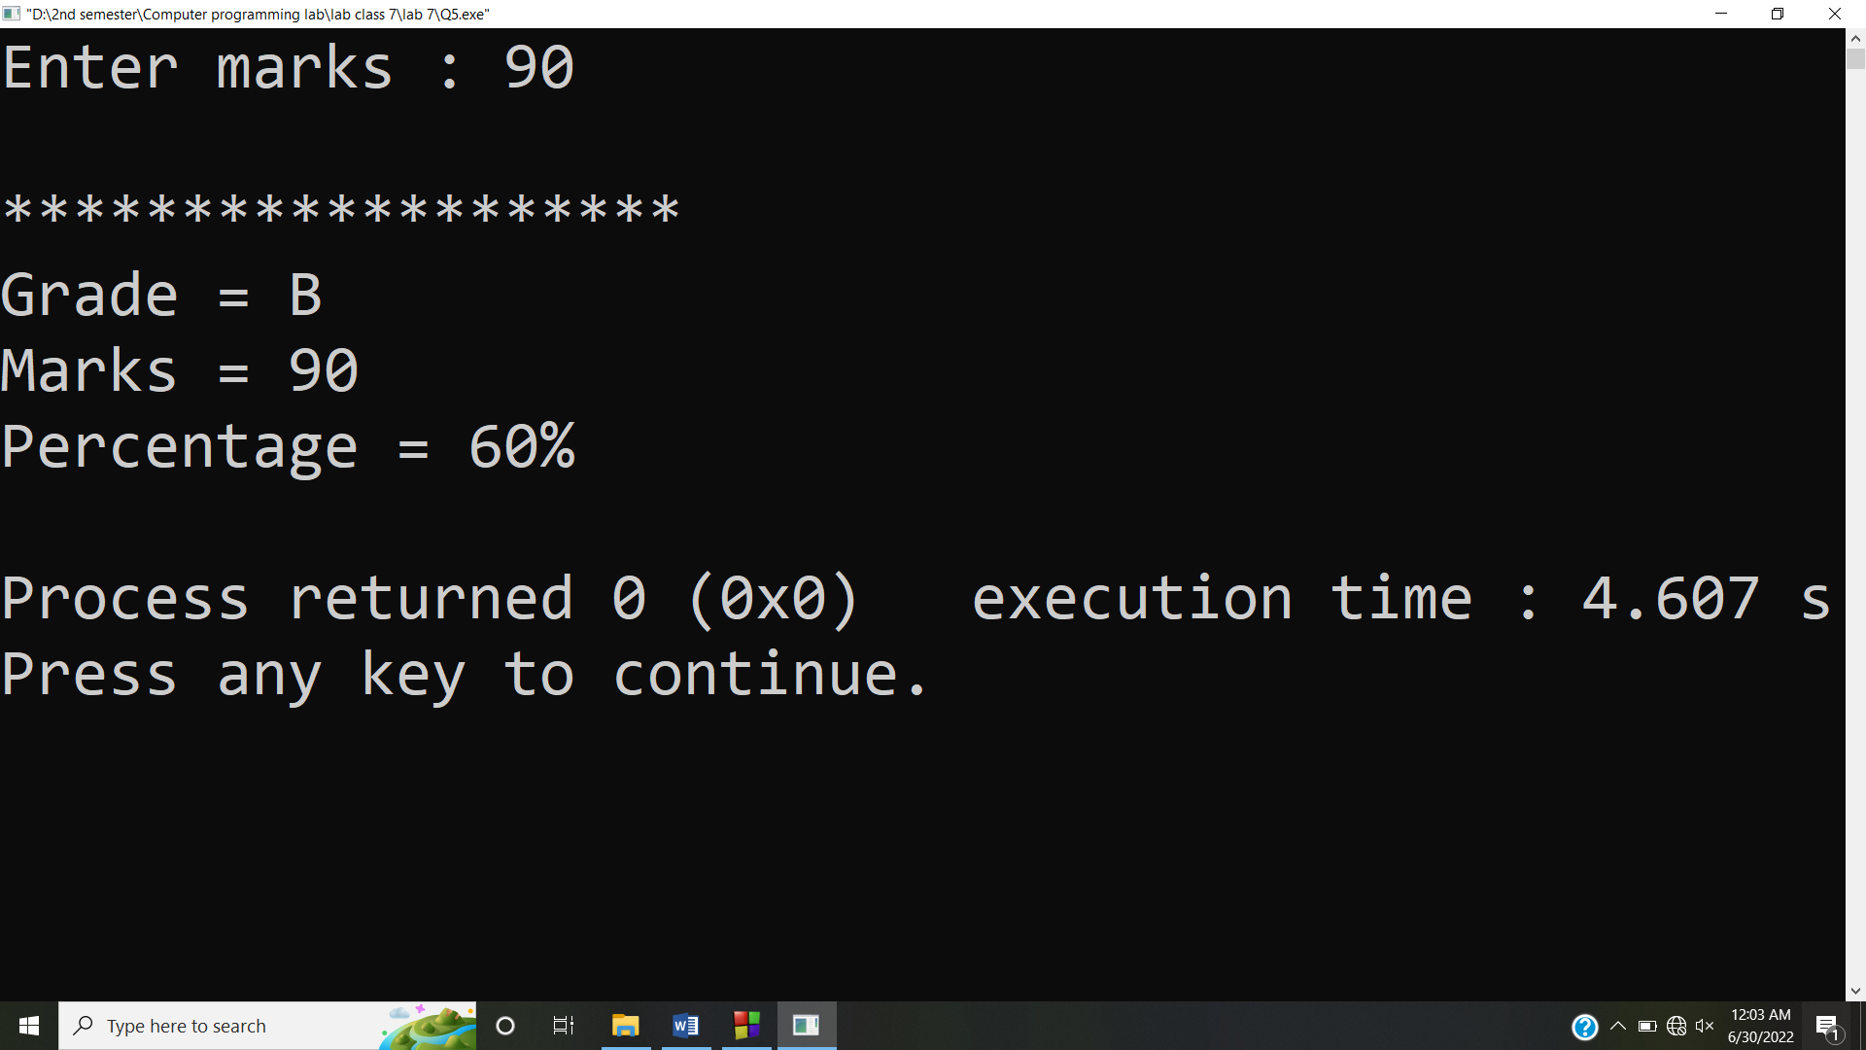

**Answer #6**

**CODE:**

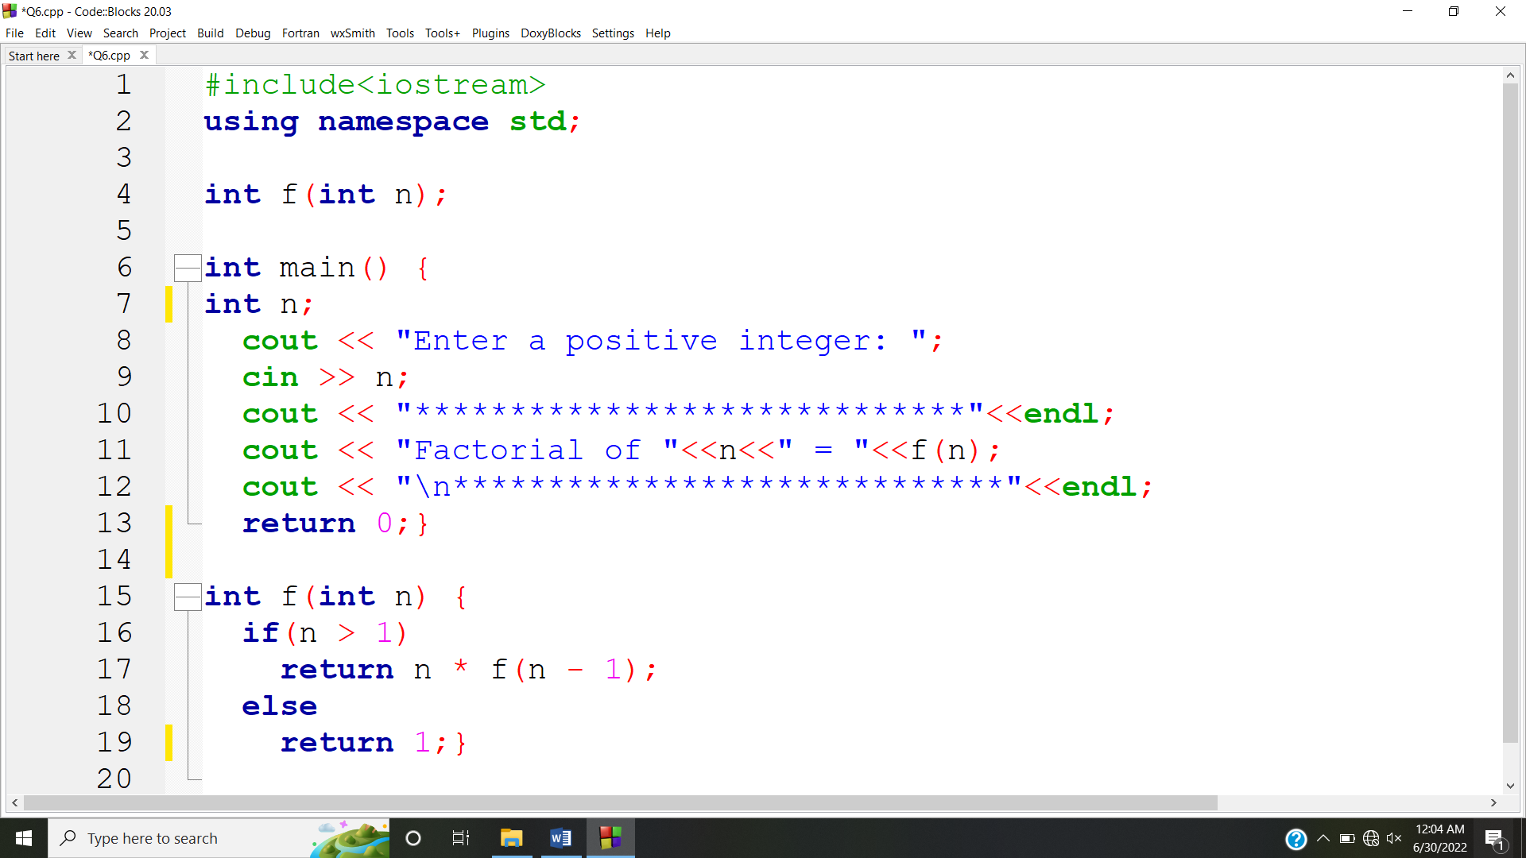

**OUTPUT:**

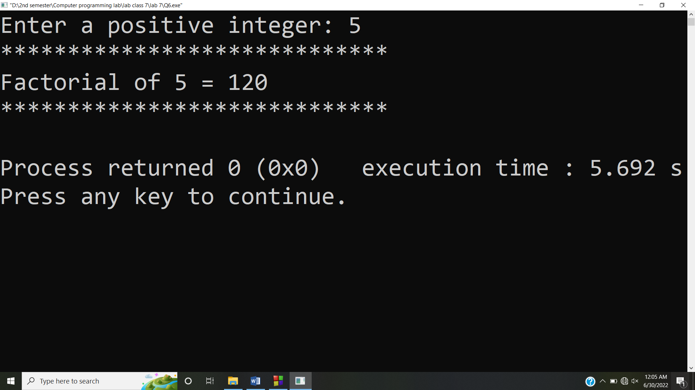

**Answer #7**

**CODE:**

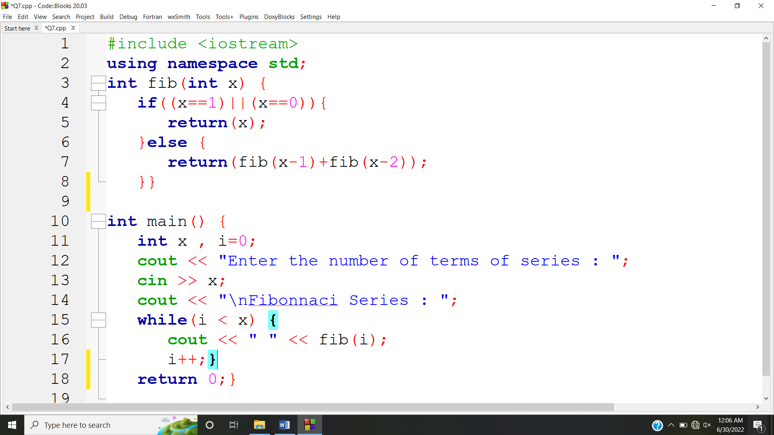

**OUTPUT:**

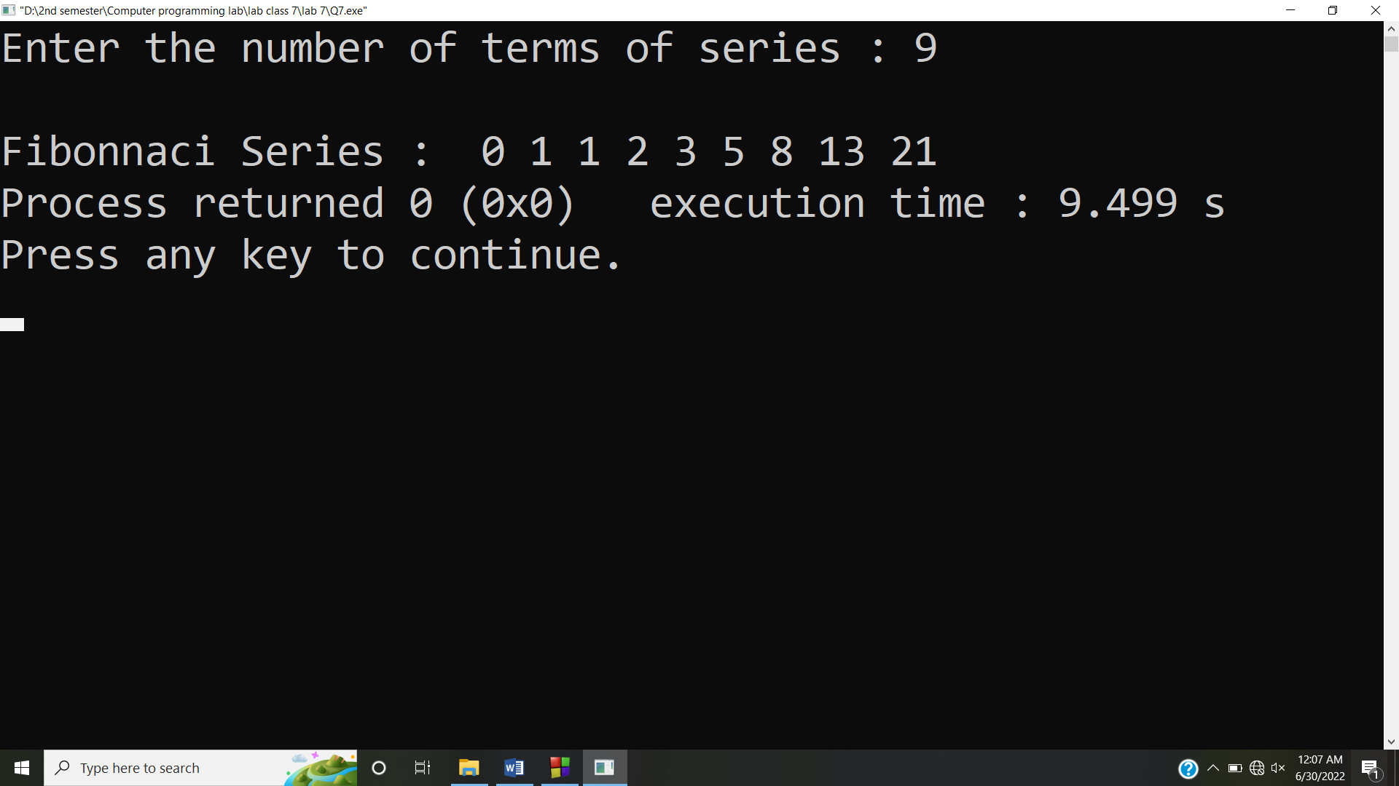

**Answer #8**

**CODE:**

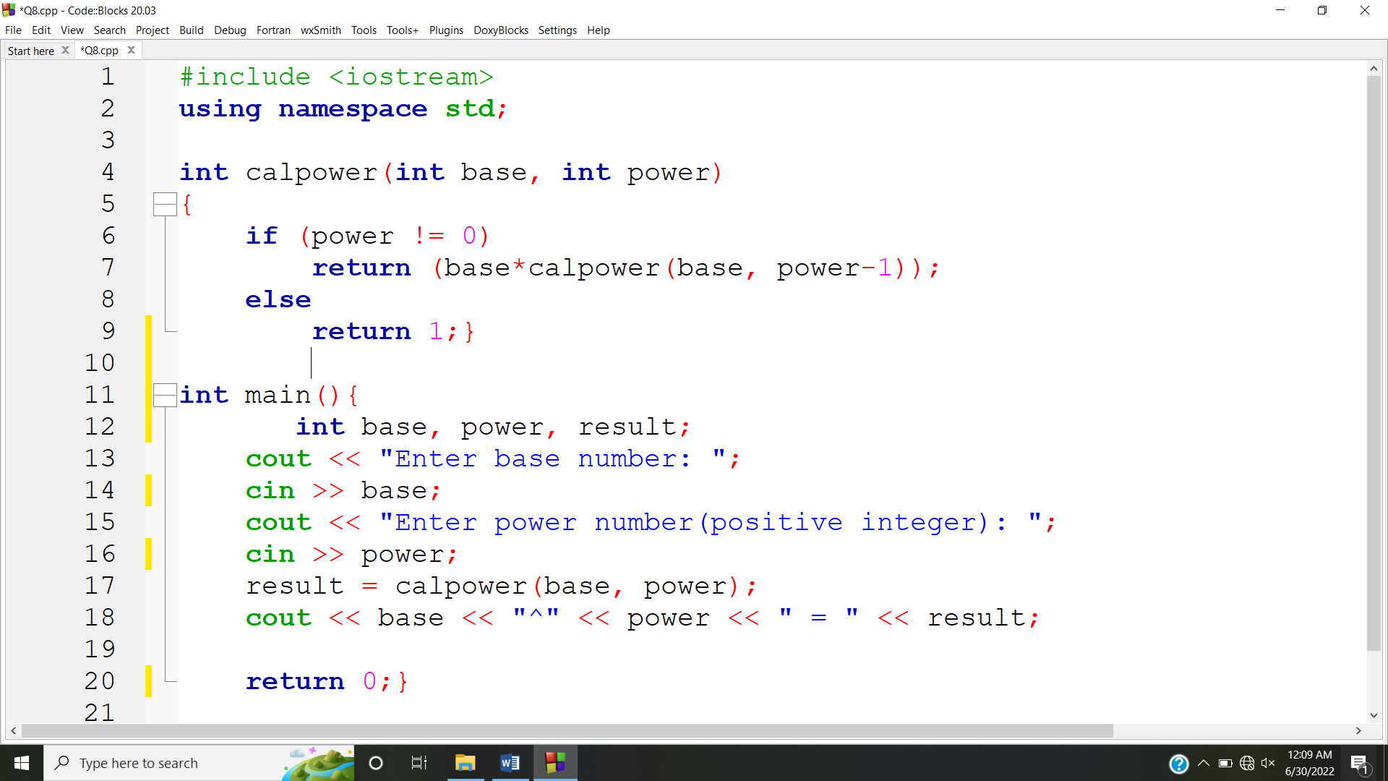

**OUTPUT:**

